Name: ____________________________ Surname: ____________________________ N^{ber}: ____ Grade/Class: _____
Assessment: _____________________________  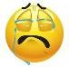  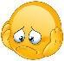 | Date: ___________________________________________________
 | Teacher’s signature:  ___________________________ | Parent’s signature:  ___________________________

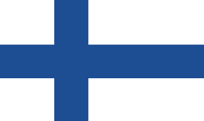
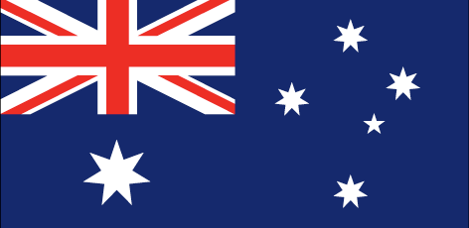
Fill in the crossword with the correct country.
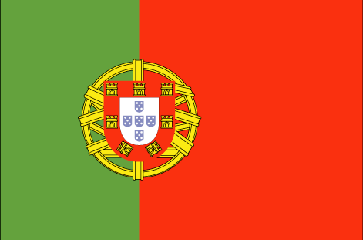
1. 2. 3. 4. 5.

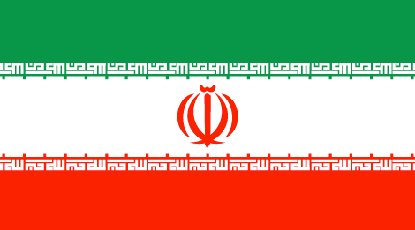
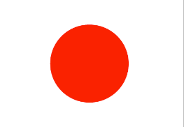
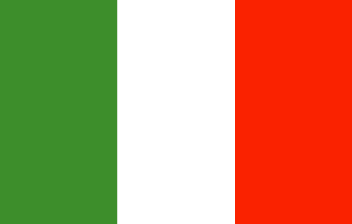
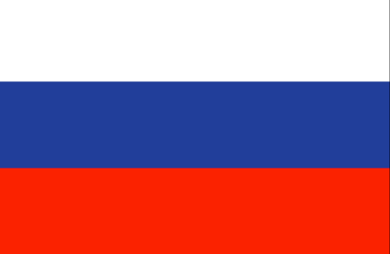
6. 7. 8. 9. 10.

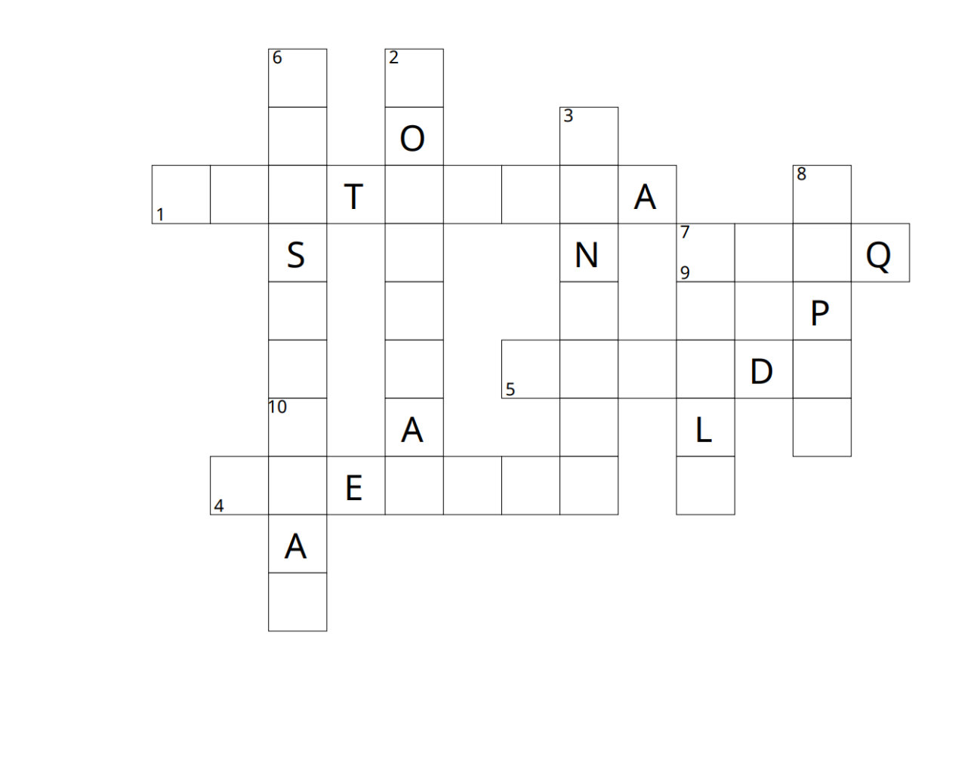

Key:
