Name: ____________________________ Surname: ____________________________ N^{ber}: ____ Grade/Class: _____
Assessment: _____________________________ | Date: ___________________________________________________
 | Teacher’s signature:  ___________________________ | Parent’s signature:  ___________________________

Fill in the crossword with the nationalities
Example: A person from South Africa > South African
- Portugal 2. Pakistan 3. Japan 4. United States
5. Canada 6. Spain 7. Finland 8. United Kingdom
9. Iran 10. Germany 11. Irak 12. Ireland
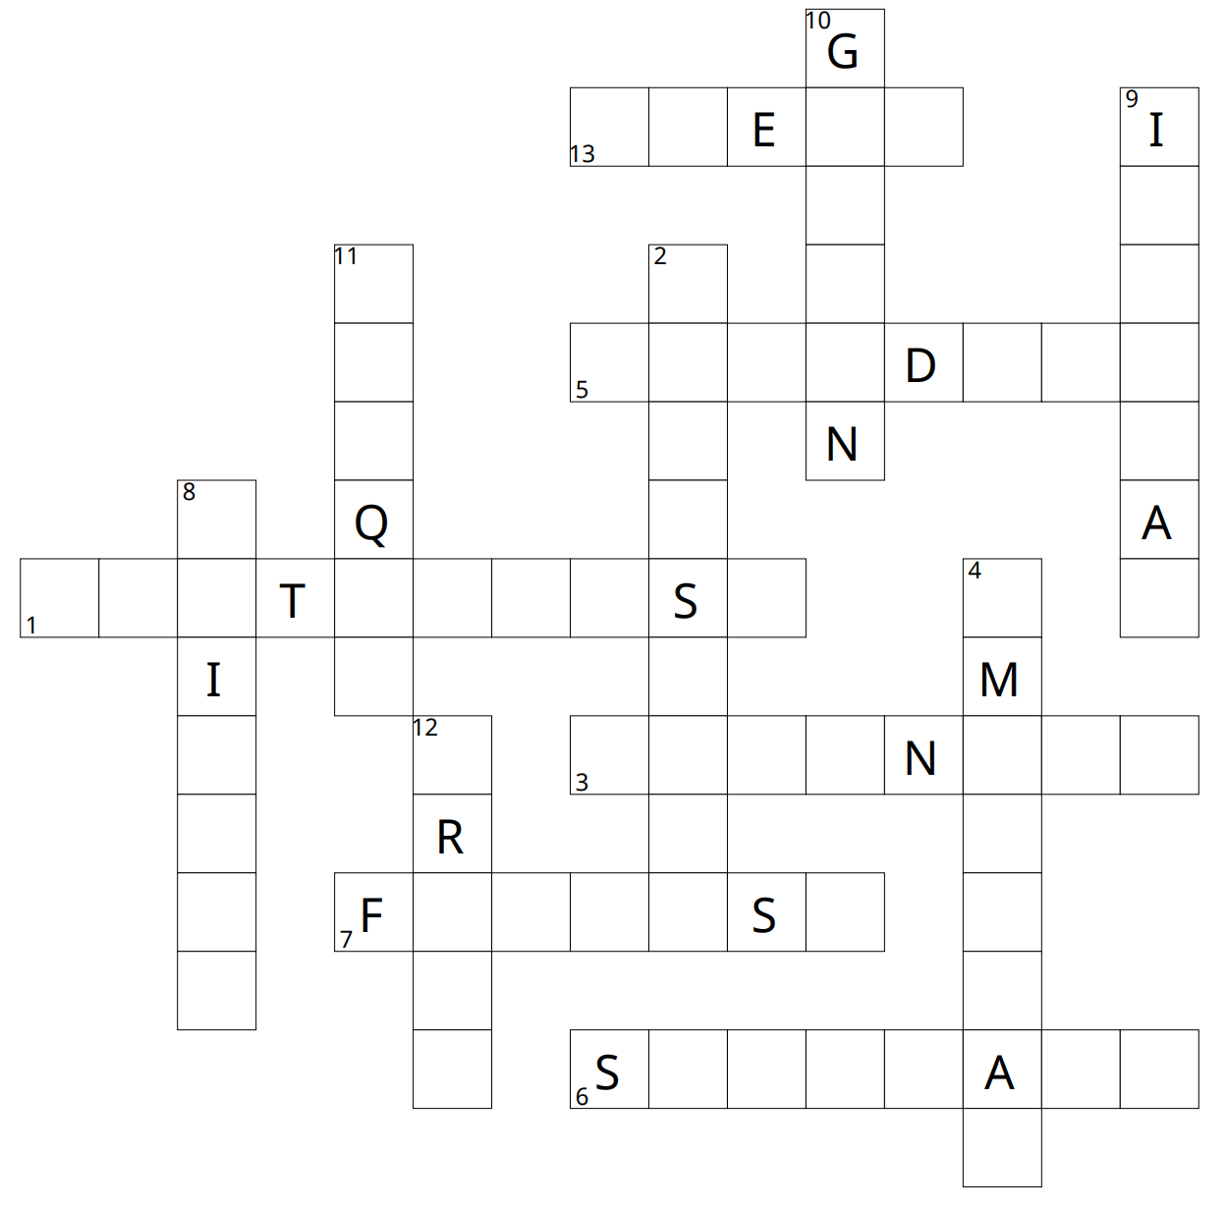
13. Greece

Key:
