Name: ____________________________ Surname: ____________________________ N^{ber}: ____ Grade/Class: _____
Assessment: _____________________________ | Date: ___________________________________________________
 | Teacher’s signature:  ___________________________ | Parent’s signature:  ___________________________

Unscramble the country names for each flag
A D C A N A S U A S O T H U A R C A I F
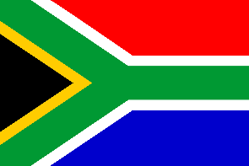
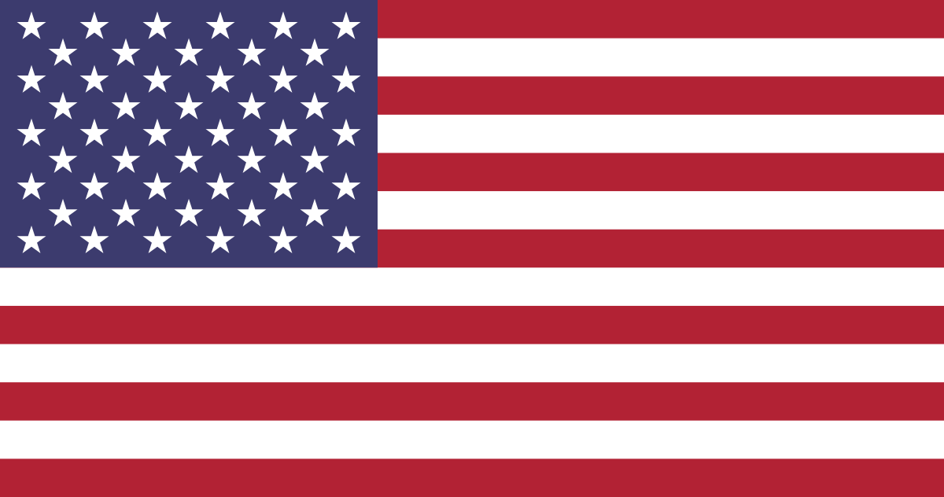
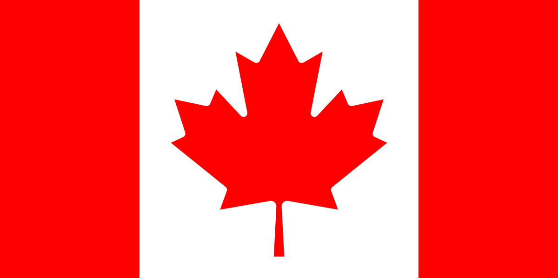

__________________ ___________________ ___________________

E W N L A N Z D A E I N A S P J N A P A
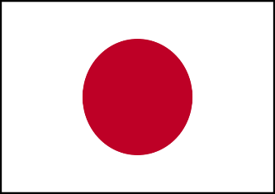
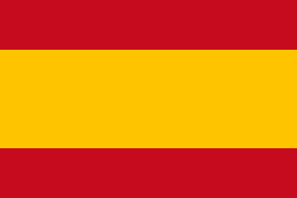
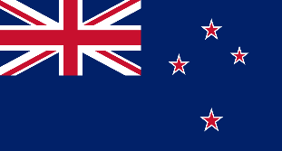
This Photo by Unknown Author is licensed under CC BY-SA

___________________ ___________________ ___________________

I A R S S U A A L A I R S T U N I A R
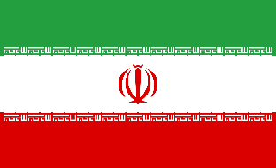
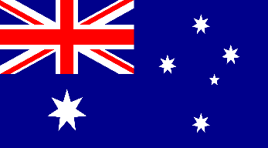
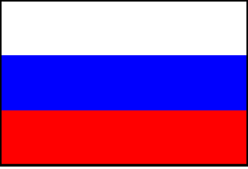

___________________ ___________________ ___________________

Key:
- Canada
- USA
- South Africa
- New Zealand
- Spain
- Japan
- Russia
- Australia
- Iran

