Name: ____________________________ Surname: ____________________________ N^{ber}: ____ Grade/Class: _____
Assessment: _____________________________ | Date: ___________________________________________________
 | Teacher’s signature:  ___________________________ | Parent’s signature:  ___________________________

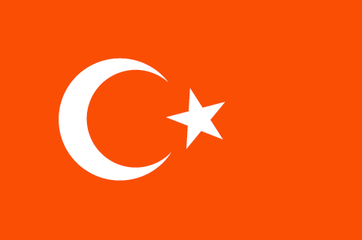
- Write and match.
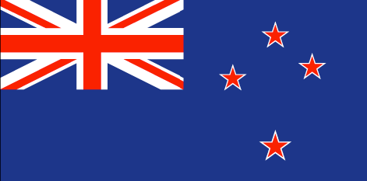
- C__na__a
- __n__t__d State__ o__ __me__ica
- S__u__h A__ri__a
- A__str__lia
- Ne__ Zel__nd
- J__p__n
- R__ss__a
- P__kis__an
- Ir__ __and
- Ir__q
- U__ite__ Kin__do__
- Turkey

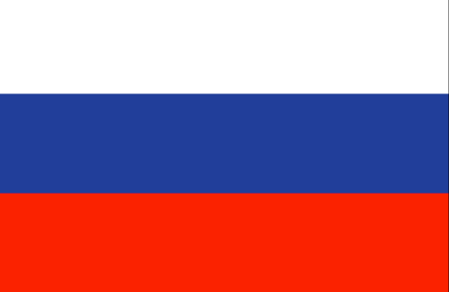
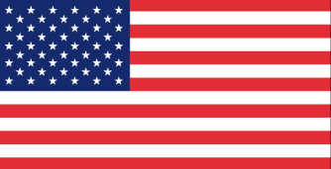

2) Answer.
Where are you from? I am from ___________________

