Name: ____________________________ Surname: ____________________________ N^{ber}: ____ Grade/Class: _____
Assessment: _____________________________ | Date: ___________________________________________________
 | Teacher’s signature:  ___________________________ | Parent’s signature:  ___________________________

- Fill in the right nationality or country.

An ________________ is a person who comes from the Unites States of America.
People who come from Turkey are ________________.
A Portuguese person comes from ________________.
A ________________ is a person who comes from Canada.
People who come from Australia are called ________________.
A Turkish person comes from ________________.
A ________________ is a person who comes from South Africa.
People who come from Ireland are called ________________.
A Greek person comes from ________________.
People who lives in the United Kingdom are called ________________.
People who come from Russia are called ________________.

- Match the nationality with the country and flag
Australian Greece
American Turkey
Portuguese Portugal
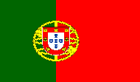
Canadian Ireland
This Photo by Unknown Author is licensed under CC BY-SA
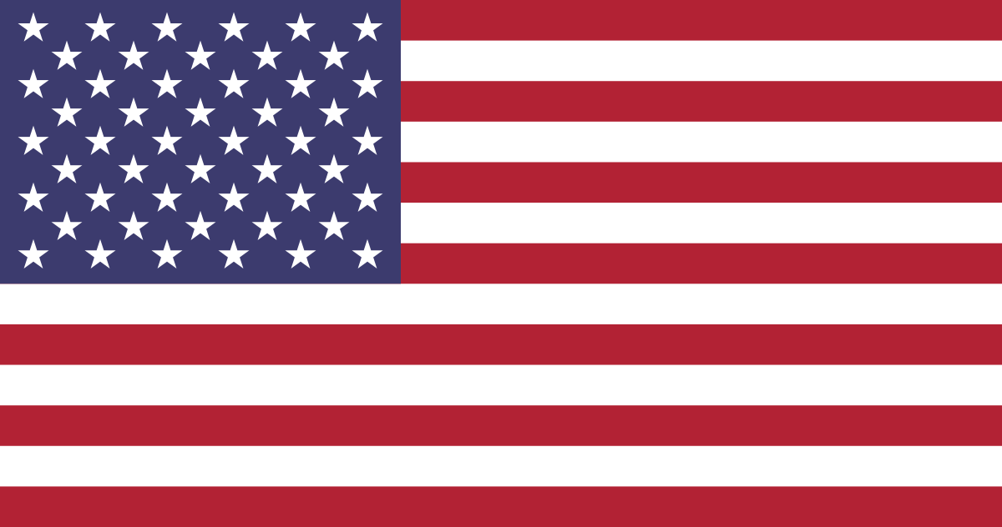
Irish Australia
This Photo by Unknown Author is licensed under CC BY-SA
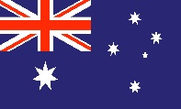
South African Canada
This Photo by Unknown Author is licensed under CC BY
Greek USA
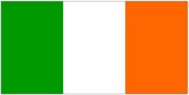
Turkish South Africa

