



**ITALY**

*Where is he from?

……………………………………………

*What nationality is he ?

…………………………………………..

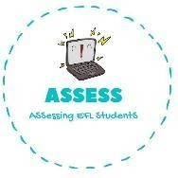ENGLISH WORKSHEET

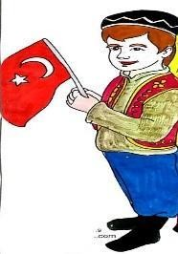

*Where are you from?

……………………………………………

*What nationality are you?

…………………………………………..

**TURKEY**





*Where is she from?

……………………………………………

*What nationality is she ?

…………………………………………..

**SPAIN**

*Where are you from?

……………………………………………

*What nationality are you ?

…………………………………………..

**ENGLAND / BRITAIN**



*Where is he from ?

……………………………………………

*What nationality is he ?

…………………………………………..

**EGYPT**

**JAPAN**

*Where is she from?

……………………………………………

*What nationality is she ?

…………………………………………..

**GERMANY**

*Where is he from?

……………………………………………

*What nationality is he ?

…………………………………………..

**CHINA**

*Where is she from?

……………………………………………

*What nationality is she ?

…………………………………………..

**FRANCE**

*Where is she from?

……………………………………………

*What nationality is she ?

…………………………………………..

**AMRICA / The USA**

*Where is she from?

……………………………………………

*What nationality is she ?

…………………………………………..



**RUSSIA**

*Where is he from?

……………………………………………

*What nationality is he ?

…………………………………………..

**AUSTRALIA**

*Where is he from?

……………………………………………

*What nationality is he ?

…………………………………………..