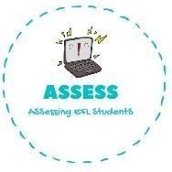
ENGLISH EXAM

Reading

Name: Surname: N^{ber}: Grade/Class:
Assessment: | Date:
 | Teacher’s signature:  _ | Parent’s signature:

Read and fill the space using the pictures.

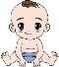
Hello, my name is Anna. My f is great. I have a little b and an older 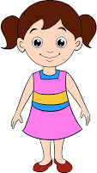 s . My f works a lot every day and my m helps me with my homework. My g loves me and gives me sweets, and my
g reads fairytales.

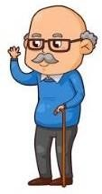
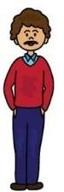Fill the gaps with the correct option.

a)

A) My father has brown hair.
B) My brother is a baby.
C) This is my family, I have a brother and a sister.
D) My grandfather tells me stories.

Assessing EFL Students

