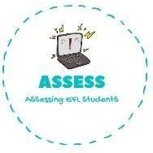
ENGLISH EXAM

Reading

Name: Surname: N^{ber}: Grade/Class:
Assessment: | Date:
 | Teacher’s signature:  _ | Parent’s signature:

- Fill the gaps with the correct option.

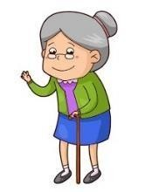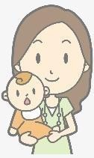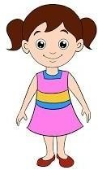D) My sister plays with me.

F) My mother is beautiful.
G) My grandma loves me.

- Read and circle.

Example: He am / / are my brother.
is

- Have / has you got a brother?

- Yes, I have / has.

- I have / has a little sister.

- My grandpa am / is / are old.
- My father have / has two brothers.

- She am / is / are my mother.

- They am / is / are my family.

- I haven’t / hasn’t got a brother.

Assessing EFL Students

