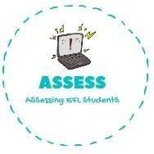
ENGLISH EXAM
Reading

Name: Surname: N^{ber}: Grade/Class:
Assessment: | Date:
 | Teacher’s signature:  _ | Parent’s signature:

- Answer the questions: YES or NO.

Do you have a brother? | YES NO
Do you have a sister? | YES NO
I have a brother. | YES NO
I have a sister. | YES NO

- Read the sentences and answer the questions.

Hello, my name is John. I have a big family. My father’s name is Tom and my mother’s name is Helen. I have a little brother. He is 4 years old. I have a sister too. She is 10 years old. My grandfather is 70 years old and reads me fairytales. My grandmother’s name is Maria and she is 68 years old. They are great. |  | - What is his father’s name?  His father’s name is .  - How old is his brother?  His brother is years old.  - How many brothers and sister has he?  He has a and a .  - What does his grandfather?  His grandfather reads .  - How old is his grandmother?  His grandmother is years old.

Assessing EFL Students

