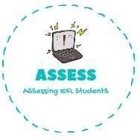
ENGLISH EXAM
Reading

Name: Surname: N^{ber}: Grade/Class:
Assessment: | Date:
 | Teacher’s signature:  _ | Parent’s signature:

1. Choose the correct answer.
Sister Brother Mother
Father Grandfather Sister
Grandmother Brother Sister
Grandfather Grandmother Brother
Brother Mother Father
Sister Grandmother Brother

Assessing EFL Students

