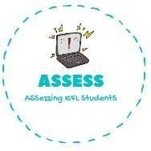
ENGLISH EXAM
Reading

Name: Surname: N^{ber}: Grade/Class:
Assessment: | Date:
 | Teacher’s signature:  _ | Parent’s signature:

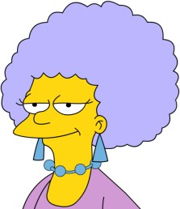
1. Choose the correct answer.

Mother Uncle Sister
Father Grandfather Aunt
Cousin Brother Grandmother

1. Answer the questions: YES or NO.

Do you have an aunt? | YES NO
Do you have an uncle? | YES NO
I have an aunt. | YES NO
I have an uncle. | YES NO

Assessing EFL Students

