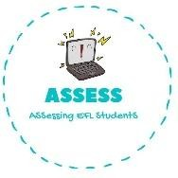
ENGLISH EXAM

Speaking

Name: Surname: N^{ber}: Grade/Class:
Assessment: | Date:
 | Teacher’s signature:  _ | Parent’s signature:

Look at the picture and answer the question

-Who is he?
-He is ...

Ask your partner: “Have you got ...?” Put a tick (✓) or a cross (✕)

- Have you got a brother?
- Yes I have/ No, I haven’t. I have two sisters/ I haven’t got brothers

-Have you got cousins?
-Yes I have/ No, I haven’t. I have three cousins/ I haven’t got cousins.
Assessing EFL Students

