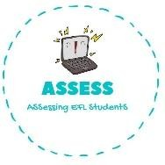
ENGLISH EXAM

Speaking

Name: Surname: N^{ber}: Grade/Class:
Assessment: | Date:
 | Teacher’s signature:  _ | Parent’s signature:

1. Ask your partner: “Have you got ...?” Put a tick (✓) or a cross (✕)

- Have you got an uncle?
- Yes I have/ No, I haven’t. I have one uncle/ I haven’t got uncles.

-Have you got aunts?
-Yes I have/ No, I haven’t. I have two aunts/ I haven’t got aunts.

-Have you got grandmothers?
-Yes I have/ No, I haven’t. I have one grandmother/ I haven’t got grandmothers.

-Have you got a friend?
-Yes I have/ No, I haven’t. I have one friend/ I haven’t got friends.

Assessing EFL Students

