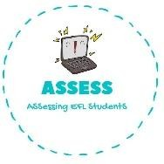
ENGLISH EXAM

Speaking

Name: Surname: N^{ber}: Grade/Class:
Assessment: | Date:
 | Teacher’s signature:  _ | Parent’s signature:

1. Look at the pictures and answer the question.
Who are they?

This is my
This is my
This is my

This is my
This is my
This is my

This is my Assessing EFL Students

