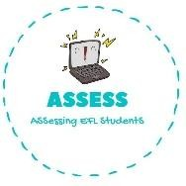
ENGLISH EXAM

Vocabulary

Name: Surname: N^{ber}: Grade/Class:
Assessment: | Date:
 | Teacher’s signature:  _ | Parent’s signature:

- Match the words and the pictures.

  - Sister

2. Mother
3. Father

4. Grandfather

5. Brother
Assessing EFL Students

