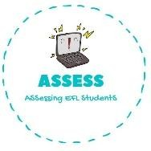
ENGLISH EXAM

Vocabulary

Name: Surname: N^{ber}: Grade/Class:
Assessment: | Date:
 | Teacher’s signature:  _ | Parent’s signature:

1. Match the words and the pictures.
1. Grandmother
2. Aunt
3. Cousin
4. Friend
5. Uncle

Assessing EFL Students

