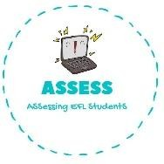
ENGLISH EXAM

Vocabulary

Name: Surname: N^{ber}: Grade/Class:
Assessment: | Date:
 | Teacher’s signature:  _ | Parent’s signature:

Order the words.

- mroteh

- faerht

- rthbero

- srseit

- mfliay

- anearfhdgrt

- ogtrdanrmhe

- nuat

- nucle

- iucnso

Choose the correct option.

Father | Grandfather | Mother
Grandmother | Aunt | Grandfather
Brother | Cousin | Sister

Assessing EFL Students

