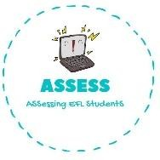
ENGLISH EXAM

Vocabulary

Name: Surname: N^{ber}: Grade/Class:
Assessment: | Date:
 | Teacher’s signature:  _ | Parent’s signature:

1. Choose the correct option.

Father | Grandfather | Sister
Grandmother | Brother | Grandfather
Sister | Father | Mother

Uncle | Grandfather | Brother
Grandmother | Mother | Grandfather
Brother | Cousin | Aunt

Assessing EFL Students

