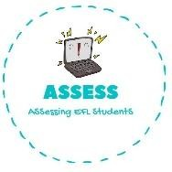
ENGLISH EXAM

Vocabulary

Name: Surname: N^{ber}: Grade/Class:
Assessment: | Date:
 | Teacher’s signature:  _ | Parent’s signature:

- Complete the crossword.

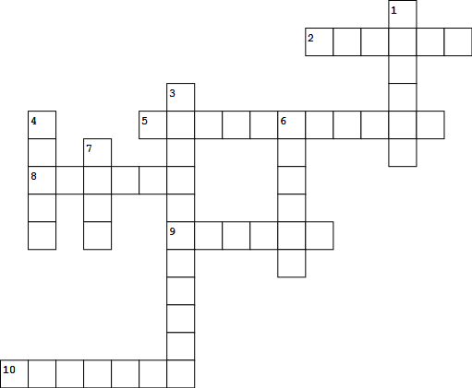

1. S_ _ t_ _
- _am_ _y
3. G_an_mo_ _ _ _
4. _nc_ _
5. _r_nd_ _ th_ _
6. F_ t_ _ _
7. A_ _ t
8. _ou_ _ _
- M er
- _ro_ h_r

Assessing EFL Students

