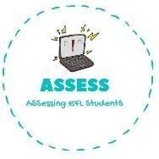
ENGLISH EXAM

Writing

Name: Surname: N^{ber}: Grade/Class:
Assessment: | Date:
 | Teacher’s signature:  _ | Parent’s signature:

- Write the correct word.

- Complete the sentences.

I have a . Have a brother? No, I .
Yes, I .

Assessing EFL Students

