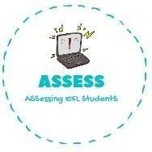
ENGLISH EXAM
Writing

Name: Surname: N^{ber}: Grade/Class:
Assessment: | Date:
 | Teacher’s signature:  _ | Parent’s signature:

1. Order the words.

T-b-h-r-e-o →
H-m-t-e-o-r →
R-f-t-a-h-e →
Y-m-f-i-a-l →
D-g-t-h-e-a-d-n-m-o-r-r →
R-g-t-e-r-n-a-t-h-d-f-a →
T-s-r-e-i-s →

Assessing EFL Students

