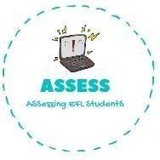
ENGLISH EXAM

Writing

Name: Surname: N^{ber}: Grade/Class:
Assessment: | Date:
 | Teacher’s signature:  _ | Parent’s signature:

1. Complete the words from the images.

F
M
A
U
B
S

Assessing EFL Students

