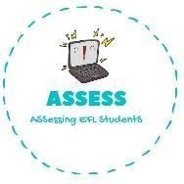
ENGLISH EXAM
Writing

Name: Surname: N^{ber}: Grade/Class:
Assessment: | Date:
 | Teacher’s signature:  _ | Parent’s signature:

- Complete the words.
- U_cle
- Au_ _
- B_ _ther
- Mo ter
- Fath_ _
- Si_ _er

- Select the family members from the previous exercise.

1. 2. 3. 4.
5. 6. 7. 8.
9.

Assessing EFL Students

