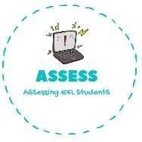
ENGLISH EXAM

Writing

Name: Surname: N^{ber}: Grade/Class:
Assessment: | Date:
 | Teacher’s signature:  _ | Parent’s signature:

Choose a family member and draw.
This is my .

↓ You can draw here ↓

Complete de sentences.

- My _ is my father’s mother.
- My is my father’s brother.
- My _ is my mother’ sister.
- I have a b_ _ and a s_ _. We have the same parents.
- My is my aunt’s daughter.
- My is my father’s father.

Assessing EFL Students

