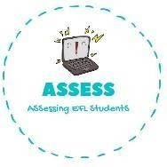
1. Listen and answer the questions.
Name: Surname: N^{ber}: Grade/Class:
Assessment: | Date:
 | Teacher’s signature: | Parent’s signature:

ENGLISH EXAM

Listening

How many brothers and sister does he have?

Is his mother brunette?

How many grandparents does he have?

How is his father physically?

Assessing EFL Students

