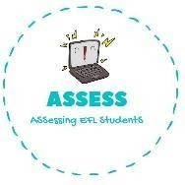
Listening
ENGLISH EXAM

Name: Surname: N^{ber}: Grade/Class:
Assessment: | Date:
 | Teacher’s signature: | Parent’s signature:

1. Listen and complete

Hello, I am Linda and I am going to describe my family. My mum is years old. She is and .
My father is years old. He is but . I have got brother and 3 . We are a big family.
I have cousins and I love when we all get for family celebrations I love my to. I hope being with them a lot of time!

Assessing EFL Students

