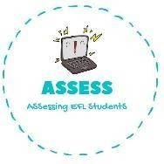
Listening
ENGLISH EXAM

Name: Surname: N^{ber}: Grade/Class:
Assessment: | Date:
 | Teacher’s signature: | Parent’s signature:

1. Listen and write true or false.

Lucy’s mum is 38 years old. Lucy’s dad is 40 years old.
Lucy has got 2 brothers and she hasn’t got
sisters.
Lucy loves having dinner with all her family everyday.
Lucy is her grandparent’s favourite.
Lucy’s dad is blonde and has blue eyes
Her mom is pregnant

Assessing EFL Students

