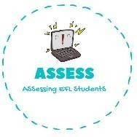
ENGLISH EXAM

Reading

Name: Surname: N^{ber}: Grade/Class:
Assessment: | Date:
 | Teacher’s signature: | Parent’s signature:

1. Read and complete with the words given.

mother | brother | grandfather | cousin | father | grandmothe  r

I love my family. My is always taking care of all the family. She is a superwoman.

I have got a big
Every Sundays we visit my They give me a lot of love.
, sometimes we fight but he makes me laugh a lot.
and my . I love the food they make for us.

Once a week, our comes to my house and spend the night with us because my aunt works a lot. I love this day; I love when we play in the garden and when my plays football with us.

Assessing EFL Students

