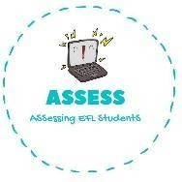
ENGLISH EXAM

Reading

Name: Surname: N^{ber}: Grade/Class:
Assessment: | Date:
 | Teacher’s signature: | Parent’s signature:

1. Read the words and find them in the puzzle.

Sister | Aunt | Dad | Brother | Son | Cousin

B | A | F | M | S | O | N
T | R | V | D | U | E | W
D | C | O | U | S | I | N
A | U | N | T | L | A | P
D | I | M | A | H | R | N
T | E | B | C | O | E | Z
E | S | I | S | T | E | R

Assessing EFL Students

