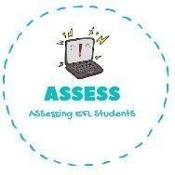
1. Read the text and answer the questions.
Name: Surname: N^{ber}: Grade/Class:
Assessment: | Date:
 | Teacher’s signature: | Parent’s signature:

ENGLISH EXAM

Reading

Hello, my name is Lucas and I am going to talk about my family. My family is very big, I have 3 brothers and 2 sisters. My mum had us when she was very young.
I love being such a big family. We live in a big house, we have different rooms, but we love sleeping together and make pyjama parties.
My dad also has a lot of brothers and sisters. They are 9 in total, so we have a lot of cousins too. At Christmas we all get together and throw big parties.
My grandmother cooks for all of us, we love her food; and my grandfather always makes us laugh with his jokes. I love my family!

- How many brothers and sisters does Lucas have?

- What thing do all the brothers and sisters love doing?

- How many brothers and sisters does Lucas’s dad have?

- Who is the person in the family who cooks at big parties?

Assessing EFL Students

