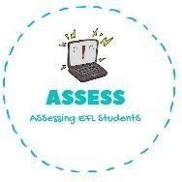
1. Read and write true or false
Name: Surname: N^{ber}: Grade/Class:
Assessment: | Date:
 | Teacher’s signature: | Parent’s signature:

ENGLISH EXAM

Reading

I have a small family. I don’t have brothers or sisters. But I love being only son. My mum has no brothers or sisters and my dad only has one sister. My cousin is like my brother, we are always together. He is older than me.
I love going to my grandparent’s house. My grandma cooks very well. I love my family.

I have a big family
I have two brothers
My mum hasn’t got
brothers or sisters
My dad has two sisters
My cousin is younger than me
I love my family

Assessing EFL Students

