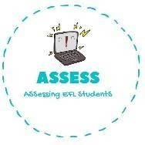
- Read and match
Name: Surname: N^{ber}: Grade/Class:
Assessment: | Date:
 | Teacher’s signature: | Parent’s signature:

ENGLISH EXAM

Reading

  - She is my mum’s mother Grandfather

  - She works a lot outside and inside the house Grandmother

  - He works a lot and takes me everywhere Mum

  - I always play with her Dad

  - He loves to tell us old stories Sister

Assessing EFL Students

