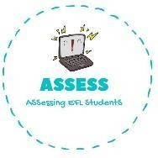
1. Ask your partner.
Name: Surname: N^{ber}: Grade/Class:
Assessment: | Date:
 | Teacher’s signature: | Parent’s signature:

ENGLISH EXAM

Speaking

A: Have you got a brother? If yes, how many brothers do you have? B:

A: Have you got a sister? If yes, how many sisters do you have? B:

A: How old is your mother?
B:

A: Do you have pets? If yes, which pet is it? B:

A: Is your father strong and tall? B:

A: How old is your grandfather?
B:

Assessing EFL Students

