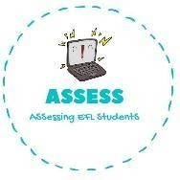
1. Ask your partner.
Name: Surname: N^{ber}: Grade/Class:
Assessment: | Date:
 | Teacher’s signature: | Parent’s signature:

How is your mother physically? Draw it:

ENGLISH EXAM

Speaking

How is your father physically? Draw it:

Assessing EFL Students

