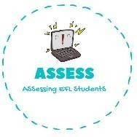
ENGLISH EXAM

Speaking

Name: Surname: N^{ber}: Grade/Class:
Assessment: | Date:
 | Teacher’s signature: | Parent’s signature:

1. Present your family to your partners.

My mum is years old.
She is

My father is years old.
He is

I have got brothers/sisters
I haven’t got brothers/sisters.

I have got / I haven’t got pets.
My pet is

Draw it:

Assessing EFL Students

