

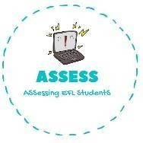**1. Answer the questions.**



|  |  |  |
| --- | --- | --- |
| **Name: Surname: Nber: Grade/Class:** | | |
| **Assessment:** | **Date:** | |
| **Teacher’s signature:** | **Parent’s signature:** |

**ENGLISH EXAM**

Speaking

 

Who are they? Who is she?

They are She is



Who are they? Who are they?

They are and They are a

Assessing EFL Students