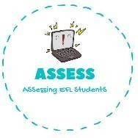
ENGLISH EXAM

Vocabulary

Name: Surname: N^{ber}: Grade/Class:
Assessment: | Date:
 | Teacher’s signature: | Parent’s signature:

1. Write the correct name for the picture.

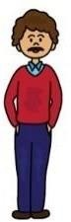

Assessing EFL Students

