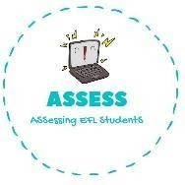
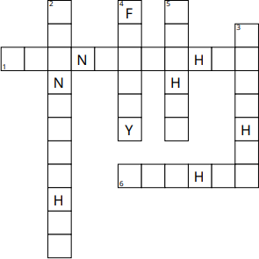
1. Complete the crosswords.
Name: Surname: N^{ber}: Grade/Class:
Assessment: | Date:
 | Teacher’s signature: | Parent’s signature:

- Grandmother
- Grandfather
- Brother
- Family
- Mother
- Father

ENGLISH EXAM

Vocabulary

Assessing EFL Students

