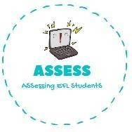
ENGLISH EXAM

Vocabulary

Name: Surname: N^{ber}: Grade/Class:
Assessment: | Date:
 | Teacher’s signature: | Parent’s signature:

- Write the names in the correct places.
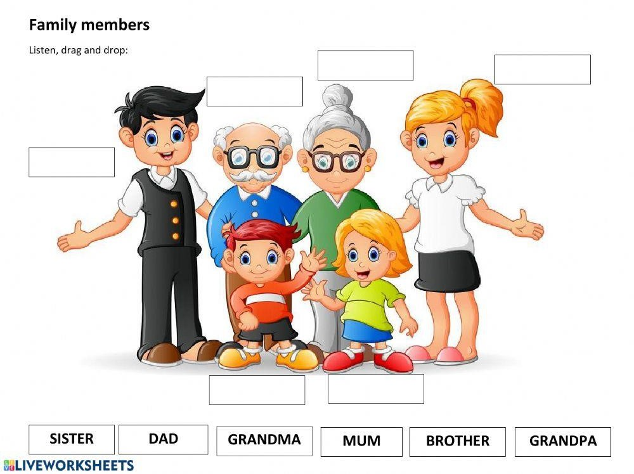

- Order the words

Usinoc ---> Taun --->
Nclue ---> Lafmyi --->

Assessing EFL Students

