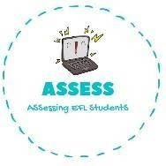
ENGLISH EXAM

Vocabulary

Name: Surname: N^{ber}: Grade/Class:
Assessment: | Date:
 | Teacher’s signature: | Parent’s signature:

1. Complete the words and match them with the pictures.

G_ _ _ _ _ _ _ _ _ _ _ | M _ _ and d _ _ _ _ _ _ _ | D _ _ and s _ _ | F _ _ _ _ _

Assessing EFL Students

