

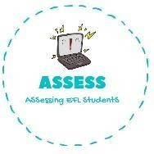1. Choose the correct option



|  |  |  |
| --- | --- | --- |
| **Name: Surname: Nber: Grade/Class:** | | |
| **Assessment:** | **Date:** | |
| **Teacher’s signature:** | **Parent’s signature:** |

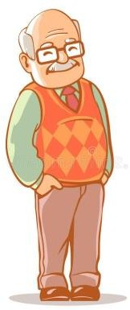



ENGLISH EXAM

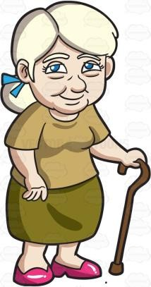Vocabulary

|  |  |  |
| --- | --- | --- |
| Grandmother | Grandmother | Father |
| Grandfather | Son | Grandfather |
| Uncle | Father | Mother |



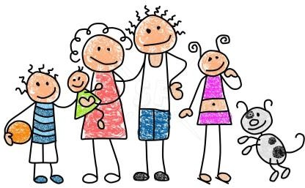

Assessing EFL Students

|  |  |  |
| --- | --- | --- |
| Son | Baby | Son |
| Mother | Father | Family |
| Daughter | Mother | Sister |