Name: Surname: N^{ber}: Grade/Class:
Assessment: | Date:
 | Teacher’s signature: | Parent’s signature:

1. Answer the questions.

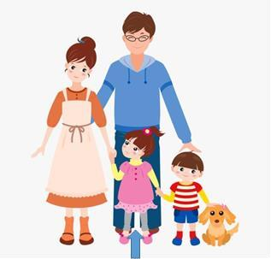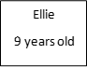

- How old is Ellie? Ellie old.

- How many brothers and sisters has she got? Ellie has .

- Does she have a pet? What is it? Yes, she has / No she hasn’t. It is .

- Is her mother beautiful? Yes, she is / No, she isn’t.

- Who is her father? Circle.

