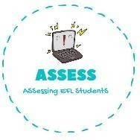
Order the family words.
Name: Surname: N^{ber}: Grade/Class:
Assessment: | Date:
 | Teacher’s signature: | Parent’s signature:

ENGLISH EXAM

WRITING

  - T-b-h-r-e-o →

  - H-m-t-e-o-r →

  - R-f-t-a-h-e →

  - Y-m-f-i-a-l →

  - D-g-t-h-e-a-d-n-m-o-r-r →

  - R-g-t-e-r-n-a-t-h-d-f-a →

  - T-s-r-e-i-s →

Answer the questions.
  - How old is your mother? → My mother years .
  - What’s your father’s name? → My father’s name .
  - How many brothers and sisters have you got? → I have _ .
  - How old is your brother / sister? → My old.
  - What’s your grandmother’s name? → My grandmother’s .
  - How old is your grandfather? → My grandfather is .

Assessing EFL Students

