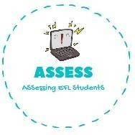
- Answer the questions
Name: Surname: N^{ber}: Grade/Class:
Assessment: | Date:
 | Teacher’s signature: | Parent’s signature:

ENGLISH EXAM

Writing

  - Who is my mother’s mother? She is my .

  - Who is my father’s father? He is my .

  - Who is my aunt’s son? He is my .

  - Who is my mother’s daughter? She is my .

  - Who is my mother’s brother? He is my .

  - Who is my father’s sister? She is my .

Assessing EFL Students

