Name: ____________________________ Surname: ____________________________ N^{ber}: ____ Grade/Class: _____
Assessment: _____________________________ | Date: ___________________________________________________
 | Teacher’s signature:  ___________________________ | Parent’s signature:  ___________________________

- Find the opposite.

- The opposite of happy is _______________.

- The opposite of energetic is_______________.
- The opposite of good is _______________.

- Match.
How do they feel?

Thirsty | sad | surprised | happy
Angry | tired | hungry | scared

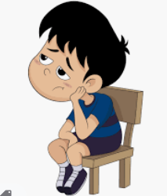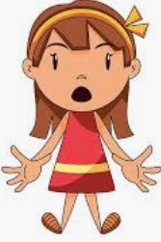
_______________ _______________ _______________
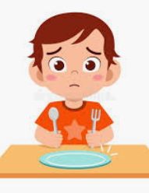
_______________ _______________ _______________
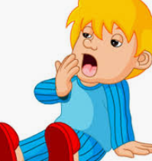
_______________ _______________

Answer key

- Sad; tired; bad

- Sad, thirsty, surprised, scared, happy, hungry, angry, tired.

