Name: ____________________________ Surname: ____________________________ N^{ber}: ____ Grade/Class: _____
Assessment: _____________________________  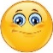 | Date: ___________________________________________________
 | Teacher’s signature:  ___________________________ | Parent’s signature:  ___________________________

- Unscramble.

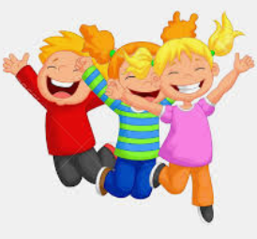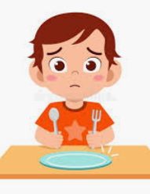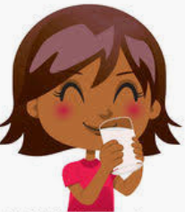

a p h a p u n h g y r r i t h t s y
________ ___________ __________
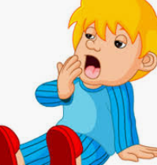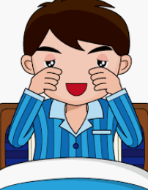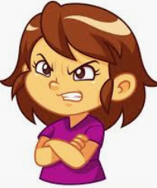
t r i d e l e p s e y n g a y r
_________ __________ __________

- Complete.

- We are h_________y. Let’s eat.
- We are t_________. Let’s drink.
- We are t_________. Let’s sleep.

Answer key
- Happy; hungry; thirsty; tired; sleepy; angry.

- Hungry; thirsty; tired.

