Name: ____________________________ Surname: ____________________________ N^{ber}: ____ Grade/Class: _____
Assessment: _____________________________ | Date: ___________________________________________________
 | Teacher’s signature:  ___________________________ | Parent’s signature:  ___________________________

- Find the words.
j s u r p r i s e d b h a p p y h u n g r y d s c a r e d h u u n h a p p y g s l e e p y c

- Label the pictures.

- ____________________ b) ____________________ c) ____________________
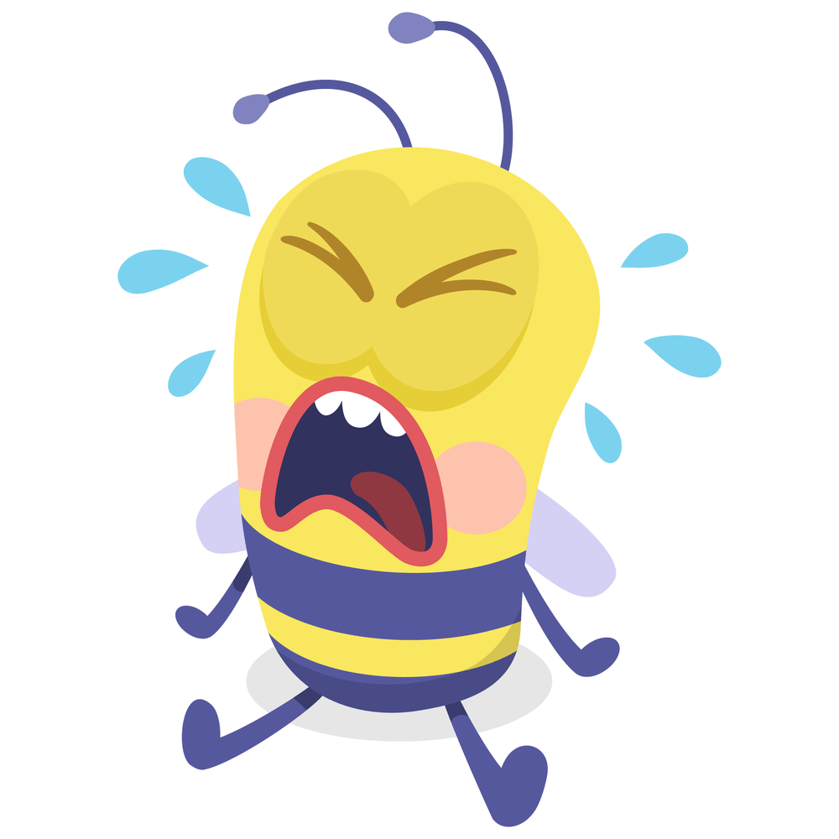

d)____________________ e) ____________________ f) ____________________

Answer key

- s u r p r i s e d h a p p y h u n g r y s c a r e d u n h a p p y s l e e p y

- A) happy, b) hungry, c) surprised d) scared, e) sad f) sleepy

