Name: ____________________________ Surname: ____________________________N^{ber}: ____ Grade/Class: _____
Assessment: _____________________________ | Date: ___________________________________________________
 | Teacher’s signature:  ___________________________ | Parent’s signature:  ___________________________

- Listen and circle the pictures.
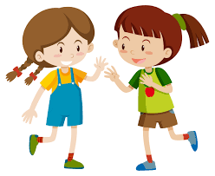
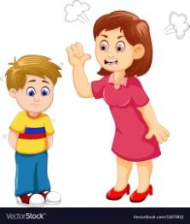
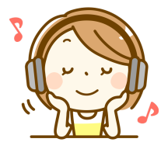

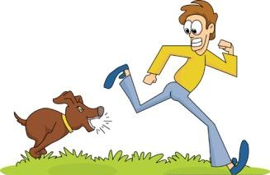

- Listen and match.

. . . . .

. . . . .

Embarased
Sad
Excited
Angry
Happy

TRANSCRIPT

EXERCISE 1

Teacher: Jane! Tell me some activities which makes you feel happy.
Jane: Ma’am, I feel happy when I do these following activities.

- Playing with friends
- Listening to music
- Eating an Ice-cream
- Cutting a birthday cake
- Reading a book

EXERCISE 2

- Cara is happy.
- Andrea is sad.
- Ronnie is angry.
- Kate is embarrassed.
- Duke is excited.

