Name: ____________________________ Surname: ____________________________N^{ber}: ____ Grade/Class: _____
Assessment: _____________________________ | Date: ___________________________________________________
 | Teacher’s signature:  ___________________________ | Parent’s signature:  ___________________________

- Listen and colour.
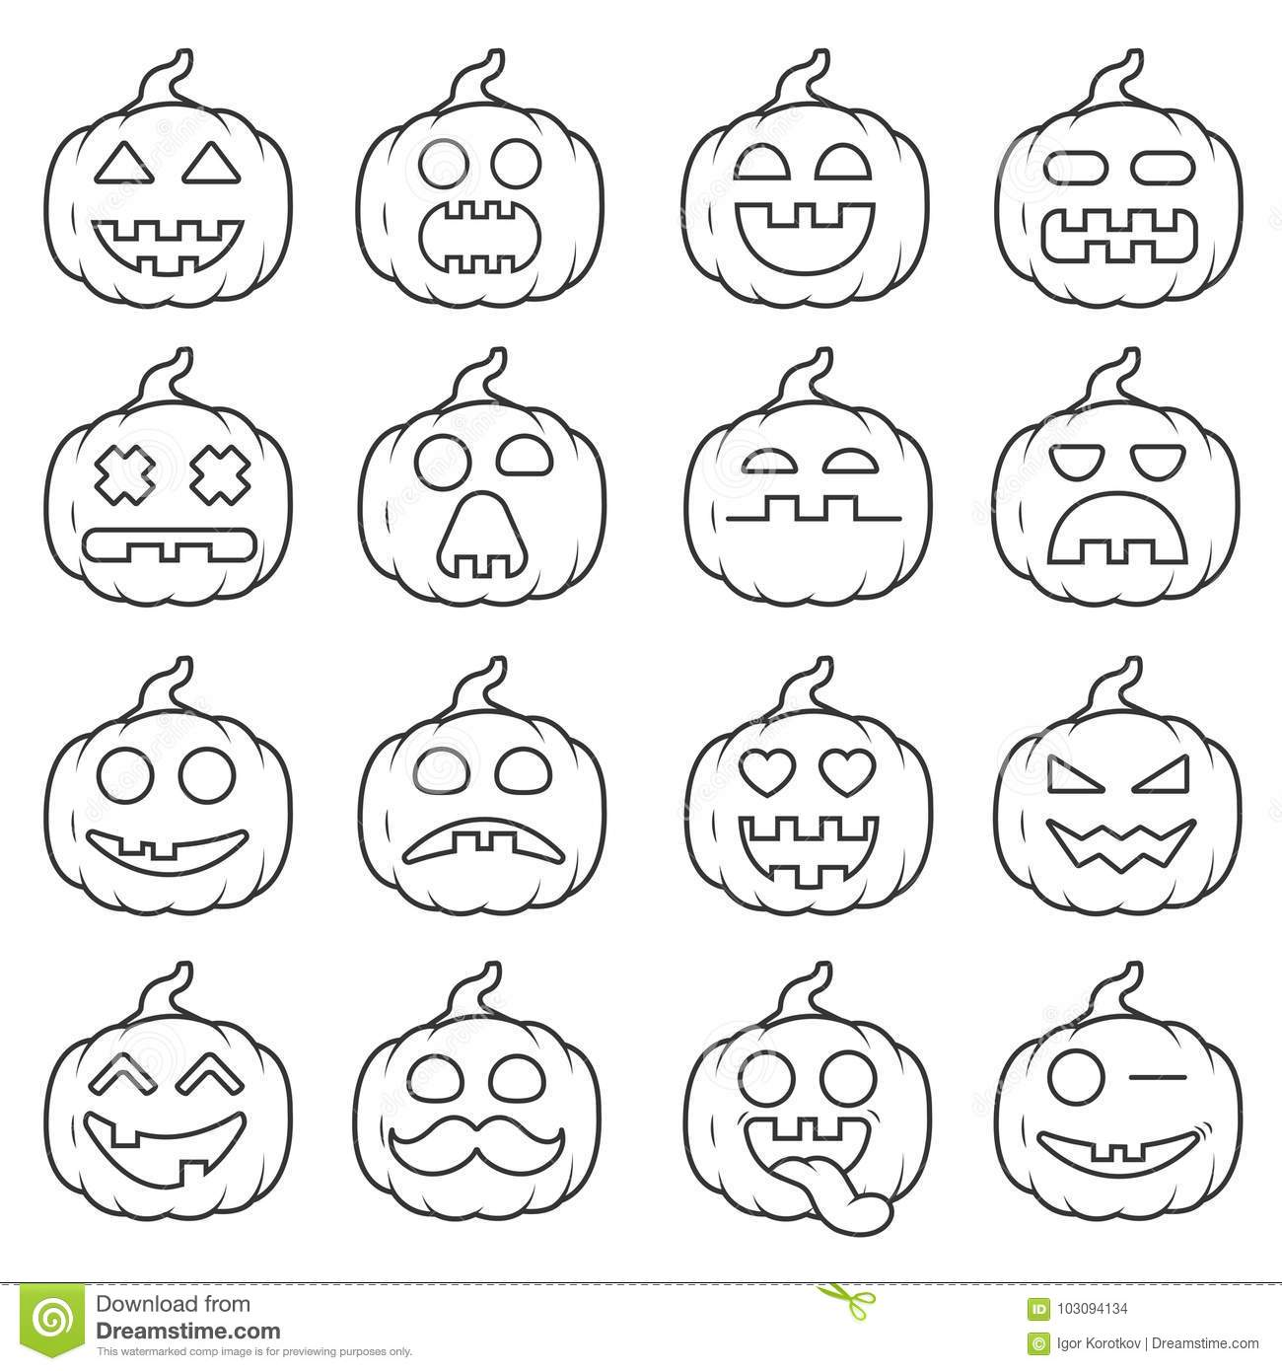

- Listen and choose.

TRANSCRIPT

EXERCISE 1

- Colour the happy pumpkins pink, in the first row.
- Colour the sad pumpkins green, in the second row.
- In the third row, colour the happy pumpkins yellow and sad pumpkins red.
- In the fourth row, colour the happy pumpkins orange.

EXERCISE 2

- Happy
- Angry
- Sad

