Name: ____________________________ Surname: ____________________________ N^{ber}: ____ Grade/Class: _____
Assessment: _____________________________ | Date: ___________________________________________________
 | Teacher’s signature:  ___________________________ | Parent’s signature:  ___________________________

Look at the picture. Circle Yes or No.
Boris Alex Zane
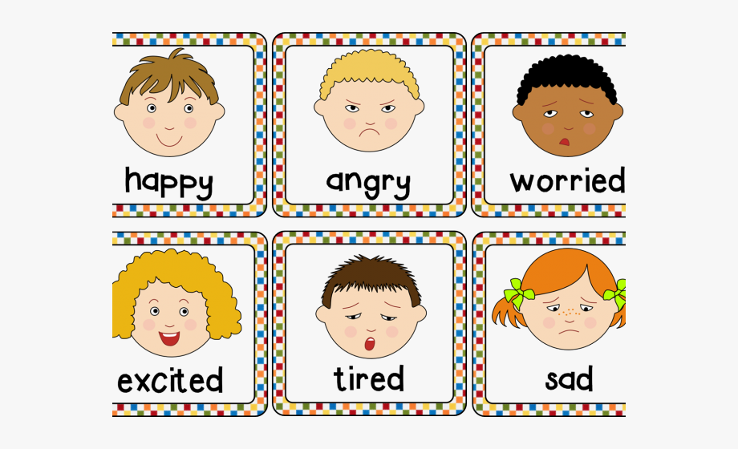
Sally Jack Amanda

a) Jack is happy. Yes No
b) Amanda is sad. Yes No
c) Sally is worried. Yes No
d) Boris is happy. Yes No
e) Zane is worried. Yes No
f) Alex is angry. Yes No

Answer key

No; Yes; No; Yes; Yes; Yes

